
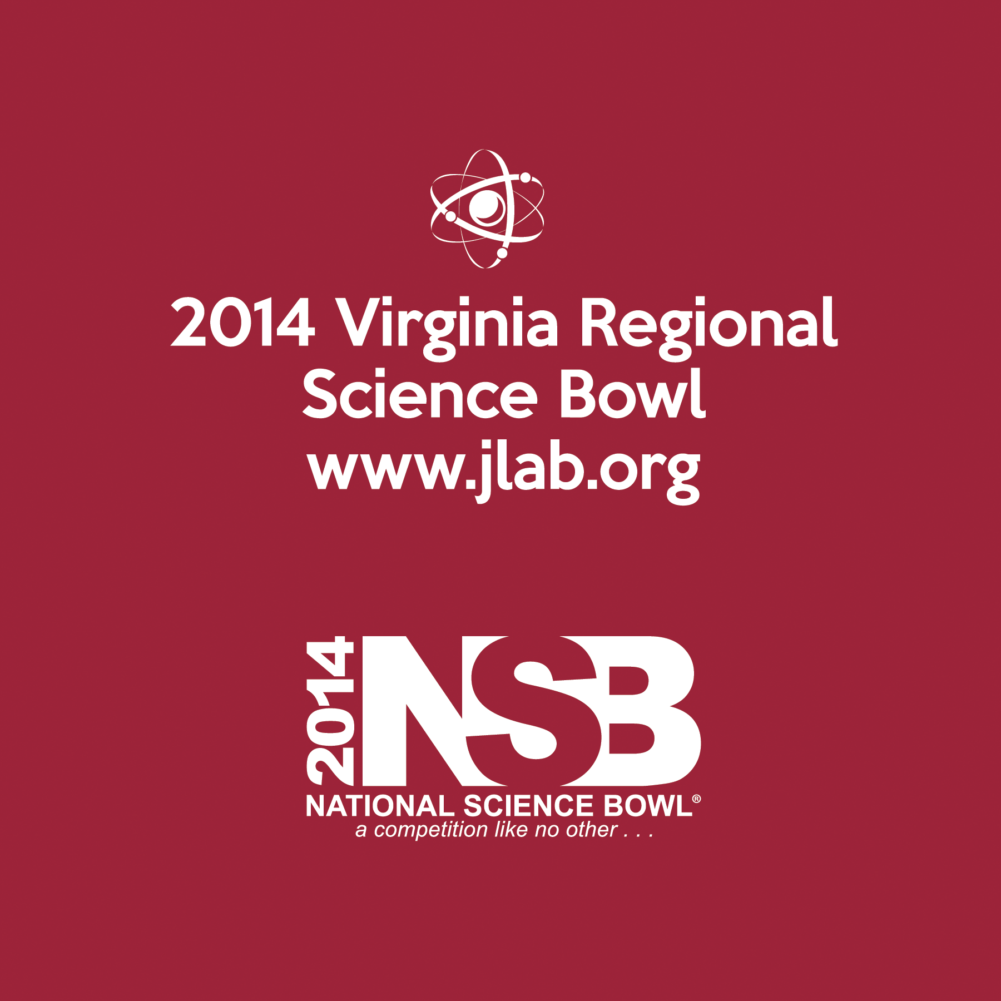
CERTIFICATE OF
PARTICIPATION

Presented to

´Fª ´Lª
´Schoolª

2014 Virginia Regional Science Bowl
Thomas Jefferson National Accelerator Facility
Newport News, Virginia
March 1, 2014


Hugh E. Montgomery, Director, Jefferson Lab

